

Personal Health Record Aggregator Syncing Data Across Multiple Hospitals/Clinics
A REPORT
In
CSA1012 –Software Engineering
Submitted in the partial fulfillment for the award of the degree
Of
BACHELOR OF ENGINEERING
IN
COMPUTER SCIENCE ENGINEERING
Submitted by:
U. Somesh Kumar (192425019)

Supervisor/Advisor Name:
Dr. K. Anita Devamani,
Professor/CSE

SAVEETHA INSTITUTE OF MEDICAL AND TECHNICAL SCIENCES
CHENNAI-602105

Table of Contents

S. No. | Contents | Page No.
1 | Cover Page | 1
2 | Index | 3
3 | Introduction | 4
4 | Problem Description | 5
5 | Scope of the System | 7
6 | Functional Requirements | 9
7 | Non-Functional Requirements | 9
8 | Use Case Descriptions | 10
9 | Use Case Diagram | 10
10 | Data Requirements | 11
11 | External Interface Requirements | 12
12 | System Features | 13
13 | Assumptions | 14
14 | Constraints | 15
15 | Requirement Validation | 15
16 | System Architecture Diagram | 16
17 | Activity Diagram | 16
18 | Entity Relationship (ER) Diagram | 17
19 | Conclusion | 18
20 | References | 18

1. INTRODUCTION
1.1 Overview
The healthcare industry generates enormous amounts of patient information through hospitals, clinics, diagnostic laboratories, pharmacies, and other healthcare providers. However, this information is usually stored in separate Electronic Health Record (EHR) systems that are not connected with one another. As a result, patients who receive treatment from multiple healthcare providers often have fragmented medical records, making it difficult for doctors to access complete health information during consultations.
A Personal Health Record (PHR) Aggregator is a patient-centric digital platform that securely collects and consolidates medical records from multiple healthcare providers into a single unified system. The platform enables patients to view their complete medical history, including prescriptions, laboratory reports, diagnostic imaging, allergies, vaccination records, and treatment history, through one secure dashboard. By adopting healthcare interoperability standards such as HL7 FHIR (Fast Healthcare Interoperability Resources), the system allows seamless exchange of health information between different hospitals and clinics while maintaining data accuracy and consistency.
The proposed system also empowers patients with full control over their personal health information by providing secure authentication, consent management, and controlled data sharing with authorized healthcare professionals. Doctors can access a patient's complete medical history with the patient's permission, reducing duplicate diagnostic tests, preventing medication conflicts, and enabling faster and more accurate clinical decision-making.

1.2 Purpose
The purpose of this Software Requirement Specification (SRS) document is to define the complete functional and non-functional requirements of the proposed Personal Health Record Aggregator Syncing Data Across Multiple Hospitals/Clinics in a structured and organized manner. This document serves as a communication bridge between stakeholders, including patients, healthcare providers, system developers, testers, administrators, and project evaluators, by clearly describing the objectives, scope, features, constraints, interfaces, and expected behavior of the system.
The SRS provides a comprehensive foundation for the design, development, testing, deployment, and maintenance of the application. It identifies the business requirements, user requirements, system functionalities, data requirements, security measures, interoperability standards, and quality attributes necessary to build a secure and reliable healthcare platform.

1.3 Need for the System
The current healthcare ecosystem consists of multiple hospitals, clinics, diagnostic laboratories, and pharmacies, each maintaining its own Electronic Health Record (EHR) system. Since these systems often operate independently, patient medical information becomes fragmented across different healthcare providers. As a result, patients are required to carry physical reports or manually explain their medical history whenever they consult a new doctor or visit a different hospital.
Table 1. Project Overview
Attribute | Description
Project Name | Personal Health Record Aggregator Syncing Data Across Multiple Hospitals/Clinics
Application Type | Web-Based Healthcare Management Platform
Target Users | Patients, Doctors, Hospitals, Clinics, Diagnostic Laboratories, Pharmacies, Administrators, Emergency Personnel
Domain | Healthcare / Health Information Management
External Platform | GitHub
Main Objective | Aggregate and synchronize patient health records from multiple healthcare providers into a single secure platform
Expected Benefit | Improve continuity of care, reduce duplicate medical tests, enhance patient safety, enable secure data sharing, and provide patients with complete control over their health records

2. PROBLEM DESCRIPTION
The healthcare industry has rapidly adopted Electronic Health Record (EHR) systems to improve patient care and digitalize medical information. However, most hospitals, clinics, diagnostic laboratories, and pharmacies maintain their own independent record management systems that are not interconnected. As a result, patients who receive treatment from multiple healthcare providers often have their medical information scattered across different institutions, making it difficult to maintain a complete and accurate medical history.
Patients are frequently required to carry physical reports, prescriptions, laboratory results, and imaging records whenever they consult a new doctor or visit a different hospital. In many cases, healthcare providers are unable to access previous treatment details, allergy information, chronic disease history, or medication records because these records remain isolated within separate hospital databases. This fragmented healthcare information increases the possibility of duplicate diagnostic tests, conflicting prescriptions, delayed diagnoses, medical errors, and higher healthcare costs
Table 2. Existing System vs Proposed System
Existing System | Proposed System
Medical records are stored separately in different hospitals and clinics. | All medical records are consolidated into a single patient dashboard.
Patients manually carry reports during consultations. | Patients can securely access and share digital health records anytime.
Limited communication between healthcare providers. | Seamless interoperability using HL7 FHIR standards.
High risk of duplicate tests and conflicting prescriptions. | Complete medical history reduces duplicate tests and medication conflicts.
Limited patient control over health information. | Patients manage consent and control access to their records.
Manual and insecure record sharing methods. | Secure encrypted sharing with authorized healthcare providers.

3. SCOPE OF THE SYSTEM
The scope of the proposed Personal Health Record (PHR) Aggregator is to provide a secure, patient-centric platform that consolidates medical records from multiple hospitals, clinics, diagnostic laboratories, and pharmacies into a single unified health record. The system enables patients to access their complete medical history anytime and from anywhere, eliminating the need to carry physical reports during medical consultations.
The application integrates with healthcare provider systems using HL7 FHIR (Fast Healthcare Interoperability Resources) standards to enable seamless and secure exchange of electronic health records. The platform automatically synchronizes patient information such as prescriptions, laboratory reports, diagnostic imaging results, vaccination records, allergies, chronic diseases, and treatment history from authorized healthcare providers into a centralized dashboard.
The system provides patients with complete control over their health information through secure authentication and consent management. Patients can grant, modify, or revoke access permissions for doctors, specialists, or healthcare institutions, ensuring that only authorized individuals can access their medical records. The platform also supports temporary and secure record sharing during consultations, referrals, or second-opinion requests.
The proposed system includes an emergency access feature that allows authorized emergency medical personnel to retrieve critical health information, such as allergies, blood group, ongoing medications, and chronic conditions, during life-threatening situations.

4. FUNCTIONAL REQUIREMENTS
Functional requirements describe the core operations that the proposed Personal Health Record (PHR) Aggregator must perform to meet the needs of patients, healthcare providers, and administrators. These requirements define how the system securely collects, stores, manages, and shares medical records from multiple hospitals, clinics, diagnostic laboratories, and pharmacies.
The system shall provide a secure registration and authentication mechanism that allows patients and authorized healthcare professionals to access the application. After successful authentication, the system shall synchronize patient health records from connected healthcare providers using HL7 FHIR (Fast Healthcare Interoperability Resources) standards. The aggregated information shall be presented through a unified dashboard that displays medical history, prescriptions, laboratory reports, imaging results, allergies, vaccinations, and treatment records.
Another important functionality of the application is consent management. Patients shall have complete control over their personal health information by granting, modifying, or revoking access permissions for doctors, specialists, hospitals, or emergency personnel. The platform shall also support temporary and secure health record sharing during consultations while maintaining detailed audit logs of every access and modification.

Table 2. Functional Requirements
Requirement ID | Description | Priority
FR-01 | Patient Registration and Login | High
FR-02 | Secure Authentication and Multi-Factor Authentication | High
FR-03 | Hospital, Clinic, Laboratory, and Pharmacy Integration | High
FR-04 | HL7 FHIR-Based Health Record Synchronization | High
FR-05 | Unified Patient Health Dashboard | High
FR-06 | View Medical History, Prescriptions, and Reports | High
FR-07 | Consent Management for Data Sharing | High
FR-08 | Secure Temporary Health Record Sharing | High
FR-09 | Medication and Appointment Reminder Notifications | Medium
FR-10 | Administrator Dashboard and System Management | Medium

5. NON-FUNCTIONAL REQUIREMENTS
Non-functional requirements define the quality attributes and performance standards that ensure the proposed Personal Health Record (PHR) Aggregator operates efficiently, securely, and reliably. Unlike functional requirements, these requirements focus on how the system performs rather than the specific operations it carries out. They ensure that the application provides a safe, scalable, user-friendly, and high-quality healthcare platform for patients and healthcare providers.
The application should provide fast and reliable access to patient health records synchronized from multiple hospitals, clinics, diagnostic laboratories, and pharmacies. Most user requests, including loading the patient dashboard, retrieving medical reports, and sharing health records, should be completed within a few seconds to provide a smooth and responsive user experience. The platform should remain available even when accessed simultaneously by a large number of users.
Security is one of the most important quality requirements of the proposed system because it manages highly sensitive medical information. All patient records must be protected using strong encryption during storage and transmission. The system should support secure authentication mechanisms, including multi-factor authentication, role-based access control, and consent-based authorization. Every access to patient information should be recorded through audit logs to ensure transparency and accountability.

6. USE CASE DESCRIPTIONS
A use case represents the interaction between users and the proposed system to accomplish a specific task. In this project, the Patient is the primary user, while Doctors, Hospital Administrators, Diagnostic Laboratories, Pharmacies, and Emergency Personnel interact with the system to access or update health records based on the patient's authorization. Healthcare Information Systems using HL7 FHIR act as external systems that provide electronic health records and synchronize patient data.
The most common interaction begins when a patient registers and logs into the application. After successful authentication, the patient links healthcare provider accounts and grants consent for data synchronization. The system securely retrieves medical records from hospitals, clinics, laboratories, and pharmacies and displays them through a unified health dashboard. Patients can view prescriptions, laboratory reports, diagnostic imaging, vaccination history, allergies, and treatment records from a single platform.
Major Use Cases
Patient Registration
Patient Login
Secure Authentication
Link Hospital/Clinic Accounts
Synchronize Health Records
View Unified Medical Dashboard
View Medical History
View Prescriptions
View Laboratory Reports
View Diagnostic Imaging Reports
Grant Consent for Data Sharing
Revoke Consent
Securely Share Health Records
Figure 1. Use Case Diagram
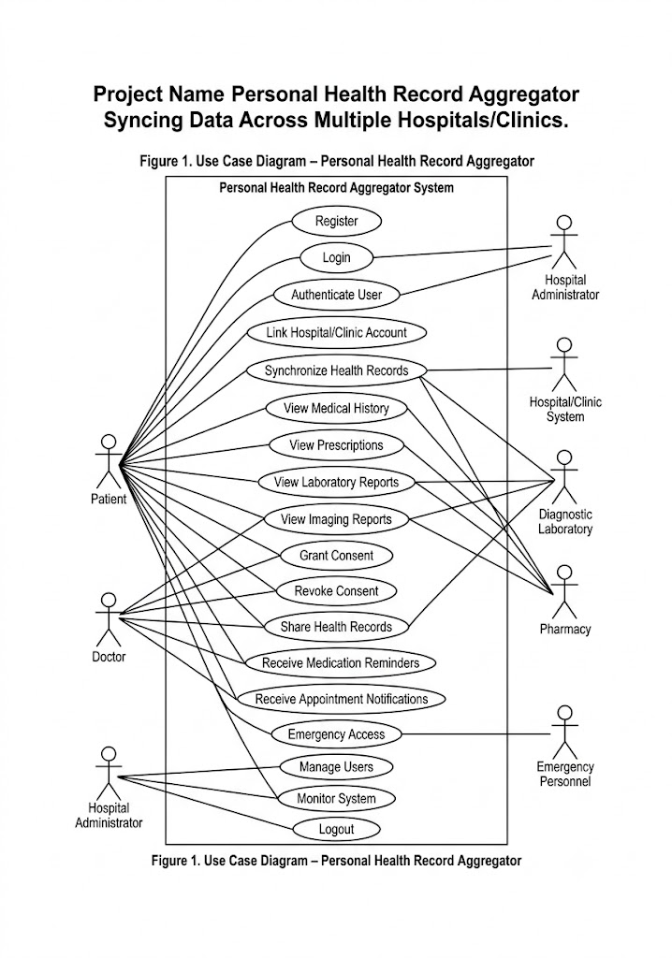
Use Case – Synchronize Health Records
Primary Actor: Patient
Precondition:
• The patient must be registered and logged into the system.
• The patient must have linked one or more hospitals, clinics, or healthcare providers.
Main Flow:
Postcondition:
The user receives a personalized list of repositories that match their programming skills and learning objectives, enabling them to begin contributing more effectively.
Main Flow
1.The patient logs into the Personal Health Record Aggregator.
2.The patient selects "Synchronize Health Records."
3.The system securely connects to authorized healthcare providers using HL7 FHIR APIs.
4.Medical records, prescriptions, laboratory reports, imaging reports, allergies, and treatment history are retrieved.
5.The system validates, consolidates, and updates the patient's unified health record.
6.The updated information is displayed on the patient's dashboard.
Postcondition:
The patient receives a complete, updated, and consolidated view of medical records from multiple hospitals and clinics through a single secure dashboard.

7. DATA REQUIREMENTS
The proposed Personal Health Record (PHR) Aggregator requires a secure and well-organized data management system to store, retrieve, synchronize, and manage patient health information collected from multiple hospitals, clinics, diagnostic laboratories, and pharmacies. The database must ensure data integrity, confidentiality, and consistency while supporting seamless interoperability using HL7 FHIR (Fast Healthcare Interoperability Resources) standards.
The system stores patient-related information such as personal details, medical history, allergies, chronic diseases, vaccination records, prescriptions, laboratory reports, diagnostic imaging results, appointments, medications, emergency contacts, and consent preferences. Healthcare provider information, including hospitals, clinics, laboratories, pharmacies, and authorized doctors, is also maintained to support secure data synchronization and access management.
The platform records every synchronization activity, consent transaction, health record update, and user access through detailed audit logs. Notification details for medication reminders, follow-up appointments, preventive health screenings, and emergency alerts are also stored to improve patient engagement and continuity of care. Sensitive patient information is protected using encryption techniques and secure authentication mechanisms to comply with healthcare privacy regulations.

Table 3. Main Database Entities
Entity Name | Purpose
Patient | Stores patient profile, login credentials, and personal information.
Doctor | Stores doctor profile and authorization details.
Hospital | Maintains hospital and healthcare provider information.
Clinic | Stores clinic details connected to the system.
Medical Record | Stores complete patient medical history and treatment records.
Prescription | Maintains prescribed medicines and dosage information.
Laboratory Report | Stores blood tests, diagnostic reports, and pathology results.

8. EXTERNAL INTERFACE REQUIREMENTS
The proposed Personal Health Record (PHR) Aggregator interacts with patients, healthcare professionals, hospitals, clinics, diagnostic laboratories, pharmacies, and external healthcare information systems through well-defined interfaces. The application is designed to provide a secure, responsive, and user-friendly experience while ensuring seamless interoperability among different healthcare providers.
The user interface consists of responsive web pages that allow patients to register, log in, synchronize health records, view their complete medical history, manage consent preferences, securely share health records with authorized doctors, and receive medication and appointment reminders. Healthcare professionals can access patient records only after obtaining proper authorization from the patient. The interface follows a consistent layout with easy navigation, dashboards, search options, and graphical reports to improve usability.
The system communicates with hospitals, clinics, laboratories, and pharmacies through HL7 FHIR (Fast Healthcare Interoperability Resources) APIs. These interfaces enable secure exchange of electronic health records, prescriptions, laboratory reports, diagnostic imaging results, allergies, vaccination records, and treatment history. Secure authentication and encrypted communication protocols ensure the confidentiality and integrity of patient data during synchronization.

User Interface
The user interface should be simple, responsive, and easy to use for patients, doctors, and healthcare administrators. Important functions such as viewing medical history, synchronizing health records, managing consent, sharing records, and receiving notifications should be accessible within a few clicks. The interface should maintain visual consistency, readable typography, intuitive navigation, and accessibility features for users of different age groups.

Software Interface
The software interface is established through HL7 FHIR APIs and hospital Electronic Health Record (EHR) systems. These interfaces enable secure synchronization of patient records, laboratory reports, prescriptions, imaging results, and treatment histories between healthcare providers and the Personal Health Record Aggregator. Integration with email and SMS notification services is also supported for appointment reminders and medication alerts.

Hardware Interface
The application requires a standard desktop computer, laptop, tablet, or smartphone with an internet connection. Since the platform is web-based, no specialized hardware is required. Healthcare providers may access the application through existing hospital computer systems, while patients can securely use their personal devices.

Communication Interface
The application communicates securely using HTTPS/TLS protocols to protect sensitive healthcare information during transmission. All communication between healthcare providers, patients, and external systems is encrypted. The platform also supports secure email notifications, SMS alerts, and API-based communication with hospital information systems while maintaining compliance with healthcare data protection standards such as HIPAA or equivalent regulations.
9. SYSTEM FEATURES
The proposed Personal Health Record (PHR) Aggregator integrates health record synchronization, secure data sharing, consent management, and patient health monitoring into a single unified platform. Each feature is designed to improve continuity of care by providing patients and authorized healthcare providers with secure access to complete medical information from multiple hospitals, clinics, diagnostic laboratories, and pharmacies.
One of the key features of the system is the Health Record Aggregation Module, which automatically synchronizes patient data from different healthcare providers using HL7 FHIR (Fast Healthcare Interoperability Resources) standards. The system consolidates prescriptions, laboratory reports, diagnostic imaging results, allergies, vaccination records, chronic disease history, and treatment summaries into a centralized dashboard. This eliminates the need for patients to carry physical medical records during consultations.
Another important feature is Consent-Based Access Control, which enables patients to manage who can view or access their medical information. Patients can securely grant, modify, or revoke access permissions for doctors, specialists, hospitals, or emergency personnel. Every access request and data-sharing activity is recorded in audit logs to ensure transparency, accountability, and compliance with healthcare privacy regulations.
10. ASSUMPTIONS
The development of the proposed system is based on several practical assumptions that simplify implementation while ensuring reliable system performance. These assumptions define the expected operating environment and user behavior during the execution of the application.
It is assumed that every user possesses a valid GitHub account and grants the necessary permissions required for accessing repository information and contribution history. Without proper authorization, the recommendation engine and contribution tracker cannot retrieve accurate repository data.
The system also assumes that users provide correct programming language preferences and technology interests during profile creation. Accurate user information allows the recommendation engine to generate relevant project suggestions and improve recommendation quality.
It is further assumed that GitHub APIs remain available and continue to provide repository information, issue labels, pull request details, and contribution history without significant changes to their functionality. Stable internet connectivity is also assumed because the application depends on real-time communication with GitHub services.
The proposed application assumes that repository maintainers correctly assign labels such as "Good First Issue" and "Help Wanted" so that beginner-friendly repositories can be identified accurately. Proper labeling significantly improves recommendation quality and user satisfaction.

11. CONSTRAINTS
Every software system operates under certain limitations that influence its design, implementation, deployment, and overall performance. The proposed Personal Health Record (PHR) Aggregator is also subject to several technical, operational, economic, legal, and time-related constraints that must be considered throughout the software development life cycle.
One of the major technical constraints is the dependency on hospital Electronic Health Record (EHR) systems and HL7 FHIR APIs for retrieving and synchronizing patient health records. Any changes in API specifications, system compatibility, or temporary unavailability of healthcare provider systems may affect data synchronization. Network connectivity is also essential because the platform relies on real-time communication with multiple healthcare providers.
From an operational perspective, the system requires hospitals, clinics, laboratories, and pharmacies to participate in the interoperability framework and maintain accurate digital health records. Patients must provide proper consent before their medical information can be shared with authorized healthcare professionals. Without user consent or provider participation, complete record aggregation may not be possible.

Table 4. Project Constraints
Constraint Type | Description
Technical | Dependency on HL7 FHIR APIs, hospital EHR systems, and continuous internet connectivity.
Operational | Requires participation of healthcare providers and patient consent for data sharing.
Economic | Cloud hosting, secure database management, cybersecurity, and maintenance costs.
Legal | Compliance with HIPAA or equivalent healthcare privacy and data protection regulations
Time | Limited time for system development, testing, deployment, and integration with healthcare providers.

12. REQUIREMENT VALIDATION
Requirement validation is one of the most important activities in software engineering because it ensures that the documented requirements accurately represent stakeholder expectations and project objectives. Validation helps identify ambiguities, inconsistencies, missing information, and conflicting requirements before software development begins.
The functional requirements have been reviewed to confirm that all major features identified in the project objectives are included within the Software Requirement Specification. Patient registration, secure authentication, health record synchronization, unified medical history dashboard, consent management, secure data sharing, emergency access, medication reminders, appointment notifications, and audit logging are clearly represented within the proposed system.
Similarly, the non-functional requirements have been validated to ensure that the system satisfies the expected standards of security, performance, reliability, availability, usability, scalability, maintainability, interoperability, and privacy. These quality attributes ensure that the platform provides a secure, efficient, and user-friendly healthcare solution while complying with healthcare data protection regulations.
13. SYSTEM ARCHITECTURE
The proposed system follows a three-tier architecture, consisting of the Presentation Layer, Application Layer, and Data Layer. This architecture improves scalability, maintainability, and overall system performance by separating the user interface, business logic, and database components.
The Presentation Layer provides an interactive web interface through which users can register, log in, connect their GitHub account, browse recommended repositories, monitor contributions, and generate portfolios. This layer communicates directly with the application server through secure HTTP requests.
The Application Layer contains the core business logic of the system. It manages user authentication, repository recommendation, contribution tracking, notification services, dashboard generation, and portfolio creation. The Recommendation Engine processes user skills and repository information to generate personalized suggestions.
The Data Layer stores user profiles, programming skills, repository information, contribution history, notifications, and generated portfolios. The system also communicates with the GitHub REST API to retrieve real-time repository information, issue labels, pull request status, and contribution history.
The identified actors, use cases, database requirements, external interface requirements, assumptions, and project constraints have also been reviewed to verify consistency throughout the document. Each functional requirement directly supports one or more system objectives, and no conflicting or redundant requirements have been identified. The requirement specification provides a clear and complete foundation for the system design, implementation, testing, deployment, and future maintenance.

Figure 2. System Architecture Diagram
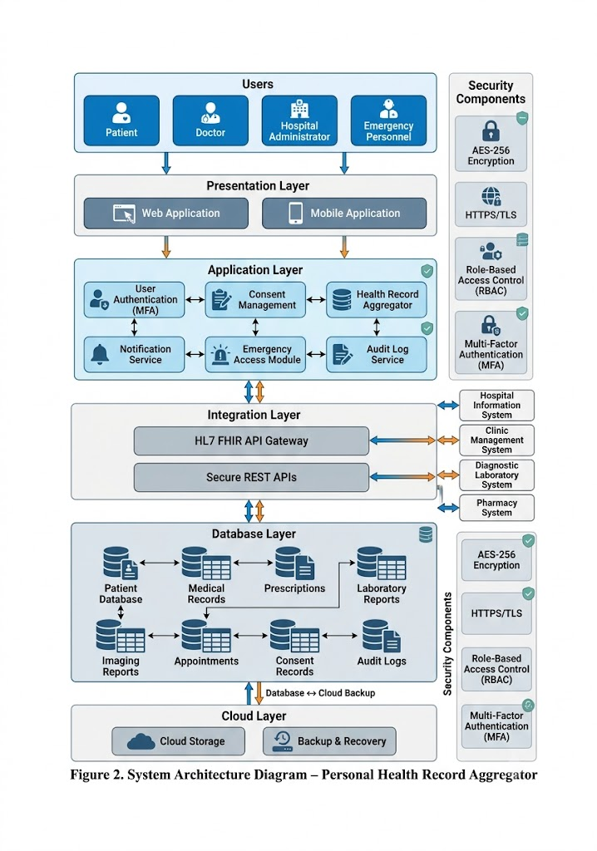
14. ACTIVITY DIAGRAM
The activity diagram illustrates the sequence of operations performed by the proposed Personal Health Record (PHR) Aggregator from patient authentication to health record synchronization and secure data sharing. It represents the workflow followed by a patient while interacting with the application and demonstrates how the system communicates with hospitals, clinics, diagnostic laboratories, and pharmacies to retrieve and manage medical records.
Initially, the patient registers and logs into the system using secure authentication. After successful login, the patient links authorized healthcare providers and grants consent for sharing medical information. The system securely connects to hospital Electronic Health Record (EHR) systems using HL7 FHIR APIs and retrieves the patient's medical history, prescriptions, laboratory reports, diagnostic imaging results, allergies, vaccination records, and treatment history.
Figure 3. Activity Diagram
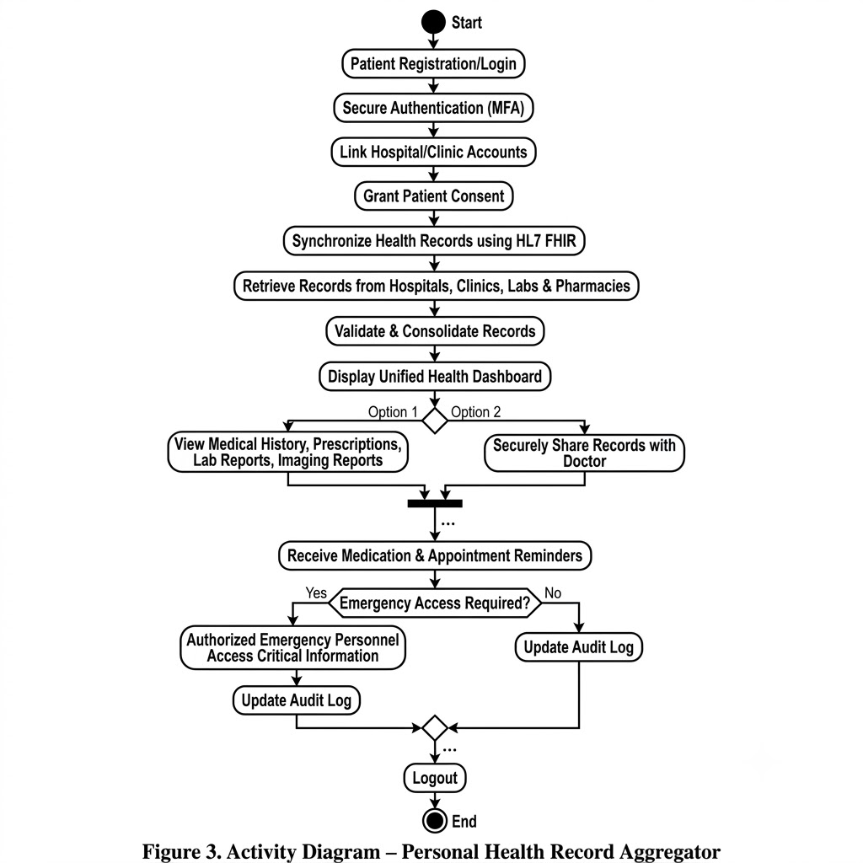
15. ENTITY RELATIONSHIP (ER) DIAGRAM
The Entity Relationship (ER) Diagram represents the logical database structure of the proposed Personal Health Record (PHR) Aggregator. It illustrates the relationships among the primary entities used by the system to securely manage patient health information collected from multiple hospitals, clinics, diagnostic laboratories, and pharmacies.
The Patient entity stores personal information, login credentials, and emergency contact details. Each patient may have multiple Medical Records, Prescriptions, Laboratory Reports, Imaging Reports, Appointments, and Notifications. The patient also manages Consent records that determine which doctors or healthcare providers can access personal health information.
Figure 4. ER Diagram
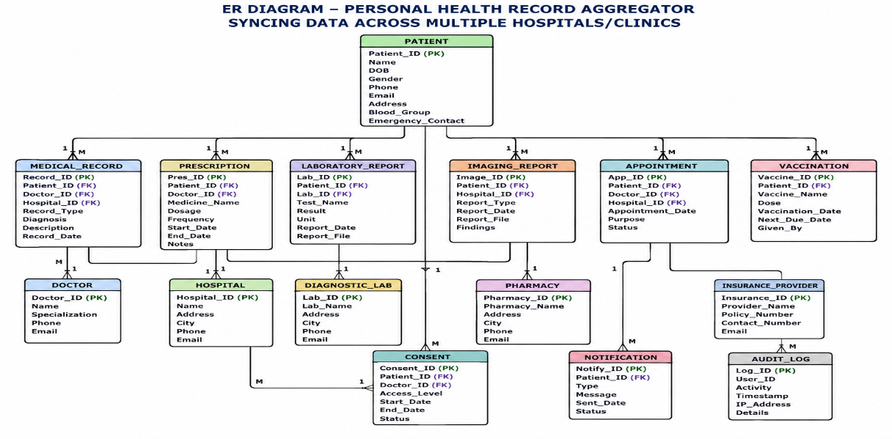
16. CONCLUSION
The proposed Personal Health Record Aggregator Syncing Data Across Multiple Hospitals/Clinics provides an effective solution to the challenges of fragmented healthcare information by integrating medical records from multiple healthcare providers into a single secure platform. By consolidating patient medical history, prescriptions, laboratory reports, diagnostic imaging results, and treatment records, the system enables patients and authorized healthcare professionals to access complete and accurate health information whenever required.
The implementation of HL7 FHIR interoperability standards, secure authentication, consent-based access control, encryption, and audit logging ensures that patient information remains confidential, accurate, and accessible only to authorized users. Features such as emergency access, medication reminders, appointment notifications, and secure record sharing further improve patient safety, continuity of care, and overall healthcare efficiency.
The modular architecture of the proposed system supports future enhancements, including integration with wearable health devices, telemedicine platforms, artificial intelligence-based health analytics, predictive disease monitoring, and personalized healthcare recommendations. These enhancements will further strengthen the platform's ability to deliver modern, patient-centered digital healthcare services.

References
1. Health Level Seven International (HL7). (2023). FHIR Release 5: Fast Healthcare Interoperability Resources. HL7 International. Available at: https://www.hl7.org/fhir/
2. World Health Organization (WHO). (2023). Global Strategy on Digital Health 2020–2025. World Health Organization. Available at: https://www.who.int
3. Office of the National Coordinator for Health Information Technology (ONC). (2024). Interoperability Standards Advisory (ISA). U.S. Department of Health and Human Services. Available at: https://www.healthit.gov
4. Raghupathi, W., & Raghupathi, V. (2022). Big Data Analytics in Healthcare: Promise, Progress, and Challenges. Health Information Science and Systems.
5. Adler-Milstein, J., Holmgren, A. J., & colleagues. (2023). Healthcare Interoperability and Electronic Health Records: Current Trends and Future Directions. Journal of the American Medical Informatics Association (JAMIA).
6. HIPAA Journal. (2024). Guide to HIPAA Compliance and Healthcare Data Security. Available at: https://www.hipaajournal.com

